Roadbook
CLIENTS



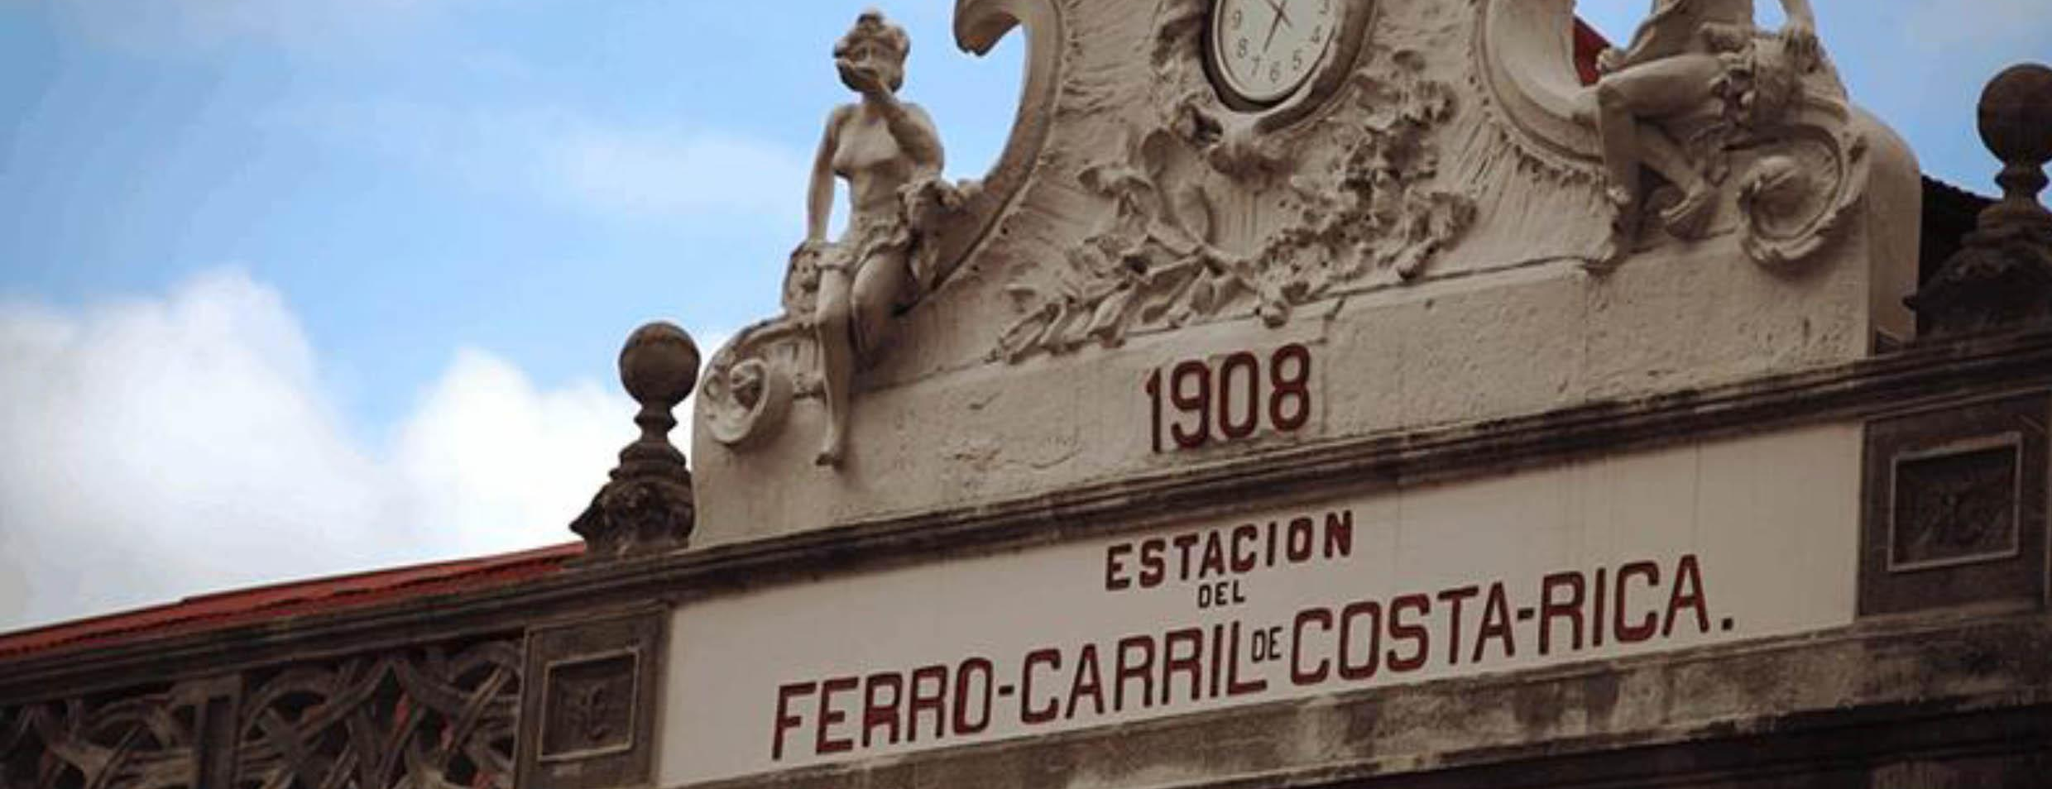
How to use your Roadbook
- Assistance
The agency is committed to offering you the best possible assistance during your trip. And in English, of course! Our advisers are available 24/7. Do you have a question, a doubt or a concern? We'll get back to you straight away.
To contact us
- Office (8am to 4pm / Monday-Friday)
- By WhatsApp and 24-hour emergency mobile phone: (506) 88 87-68 32
- User guide
Before you dive into this Roadbook and begin your colourful adventure, the Morpho Evasions team would like to welcome you to Costa Rica!
This Roadbook will be your guide to save you from many uncertainties and doubts and help you make the most of your Costa Rican experience.
- Glossary
- Good to know: General presentation of the destination or activity.
- Important information: about your booking number, telephone number, arrival time, logistics, etc.
- Please note: We will provide you with information that is important for your safety or the smooth running of your trip (compulsory timetables, restrictions to be taken into account, etc.).
General organisation
Simple and intuitive to use, this Roadbook will enable you to find all the important information for your trip at a glance: hotel telephone numbers, booking numbers, routes to your destination, day-to-day activities and lots of other valuable information.
You can find all this information in these main categories:
Itinerary
This category contains information specific to the itinerary you received digitally. So you can follow the programme drawn up with your travel consultant day by day.

Booking info
This is one of the most important categories in your roadbook. Every booking has been recorded in this roadbook. Telephone number, booking number and other information relating to your journey can be found in the box reserved for this purpose.
The road point
Another essential aspect for the success of your trip is that you'll find precise indications of the routes to take to avoid getting lost via a digital link in your digital roadbook.
Service stations and fuel
Fuel prices are set by the Costa Rican government at national level (= a single price throughout the country). At service stations, the attendant will serve you. There's no need to get out of the car. You will simply be asked what type of fuel you want (regular, super or diesel).
If you want a full tank, you can say "tanqué lleno por favor". You can pay by credit card or in cash:
Regular= Petrol, Super= Super, Diesel= Gasoil.
Included
Day by day, this small section will list the services included in your tour. These are the same services as those set out in your digital travel programme.

Practical information
In the appendix, you will find additional information to help you make the most of your trip. Emergency telephone numbers, basic vocabulary, road signs, etc. We recommend that you use a reusable water bottle so as not to pollute the sites you visit, particularly national parks or natural sites.

Zero tolerance
Sex tourism is a scourge that affects every country in the world. Unfortunately, it also affects Costa Rica. Morpho Evasions, as a member of the Protect Them code of conduct, would like to remind you that having a sexual relationship with an adolescent (a minor) is an offence punishable by imprisonment. Morpho Evasions is committed to this fight and reaffirms that there is and will be no tolerance of the sexual exploitation and assault of minors.

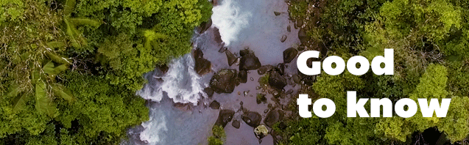

Car hire
In the event of an accident with the hire car (impact, scratch, blow, any other damage however minor), inform the car company immediately so that the insurance company can intervene if necessary.
Allow around 4,500-5,000 colones in small change; you will have to pass through various toll booths, so don't forget to choose "via manual" at the toll booth.) You can also pay by credit card if you don't have cash.
Nature walks
For safety reasons, we recommend that you hike in Costa Rica on marked trails maintained by a private or public reserve (national park, biological reserve, etc.). Entrance fees to these reserves are generally charged (between $5 and $25 per person on average); however, given the relative hostility of the natural environment and the difficulty of finding one's way around the rainforest, we recommend that our travellers take advantage of the many infrastructures open to the public to enjoy this magnificent environment that is the rainforest.

Accommodation and biodiversity
In Costa Rica, lodges are designed to blend in perfectly with nature. The planting around your cottages is varied and often provided to respect biodiversity. These beautiful, colourful gardens are home to many small insects, which can sometimes wander into your accommodation uninvited after a visit from the cleaning lady. Harmless little Gecko's also like to scour the walls of the rooms in search of their favourite food: mosquitoes. So don't be afraid! This does not mean that your lodge is poorly maintained, simply that the insects find it to their liking, just as you do.
The national parks
The national parks are one of Costa Rica's treasures. We recommend that you buy entrance tickets to the national parks (if they are not included in your holiday) via this link several days before your visit: https://serviciosenlinea.sinac.go.cr/. Please note: for these national parks, PN Cahuita, PN Marino Ballenas and PN Arenal, entrance tickets must be purchased on site.
The national parks do not allow you to bring plastic bottles with you: bring a reusable water bottle.
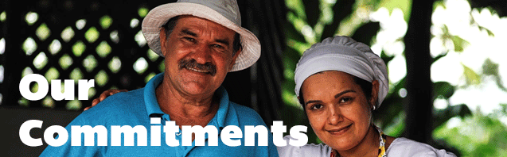

◆ Guaranteed quality
- Official agency dependent on the tourist office
- Specialist advisers who have been field guides in Costa Rica
- Regular checks on our service providers (your opinions count)

❖ Safety and peace of mind
- Rigorous selection of our partners and service providers
- Personalised follow-up from your first contact to your return home

⬥ Fair prices
- Prices without intermediaries that directly benefit local service providers

 English-speaking welcome
- You will always be greeted by an English-speaking guide or receptionist at the airport gates, so that you arrive feeling completely at ease. The tour will be debriefed at your own pace.

 Putting people at the heart of our trips
- We offer you trips on a human scale, authentic, with charming lodges far from the big tourist structures.

 24/7 assistance
- We ensure the peace of mind of your trip with a dedicated telephone line.

 Eco-responsible travel
- We are part of the coveted CST (Certificado de Sostenibilidad Turistica) label, which proves our daily commitment to sustainable, green tourism.
- Your trip helps local people. Last year, 35 families benefited from tourism development projects and advice in the Boca Tapada area in north-east Costa Rica (Project 2016-2023: Rural Life Costa Rica).

INCLUDED/NOT INCLUDED
The price includes:
- 13 nights accommodation in a double room in the superior category hotels indicated, including all hotel taxes.
- Car rental (Dahiatsu Bego 4*4 or similar) with basic insurance (from D4 to D13), GPS and unlimited mileage.
- All breakfasts + 7 additional meals.
- All land and sea transfers.
- Activities planned by the lodge in Maquenque (night tour, birdwatching and free use of canoes) with bilingual English/Spanish local guide.
- Ratfing at Rio Pacuare category III-IV.
- The bilingual English/Spanish local guide for the activities planned by the Rainforest Lodge hotel at the Rio Pacuare.
- Morpho Evasions assistance on site 24 hours a day.
- Welcome in English at the airport and handover of the route book.
The price does not include:
- International flights.
- Entrances to national parks not indicated as included.
- Meals and drinks not previously mentioned.
- Personal purchases.
- Options (additional activities).
- Petrol.
- Any tips.

