***ON BEHALF OF THE ENTIRE MORPHO EVASIONS TEAM, WE WISH YOU A PLEASANT JOURNEY.***



Travel Notes

Useful Information

Emergency numbers :

Rescue/Police/Emergencies: 911

Morpho Evasions Agency : Mobile : (506) 8887-6832

Important: Please make good use of our telephone assistance service by observing the following opening hours: (in order to spread calls over the whole day and therefore be able to react as quickly as possible to unexpected emergency situations)

- office hours: 08:30 to 16:30

Office hours: for all specific requests, advice, hotel/activity bookings or changes.

- Emergency hours: 7 days a week and 24 hours a day on the following mobile number: (506) 8887-6832: For all emergencies: flight delays/cancellations, car/personal accidents, blocked roads, etc.

Emergency centers in San José :

Costa Rican Red Cross: 128

San José: Hospital Calderón Guardia - Tel: (506) 2212-1000

Some practical words and expressions

**Hello :** Buenos días (before 12:00)/ Buenas tardes (after 12:00)

**Goodbye :** Adiós

**Thank you:** Gracias

**Please :** Por Favor

**Excuse me:** Discúlpeme

**I don't understand:** No entiendo

**Service station :** La gasolinera / la bomba

**Airport :** aeropuerto

**Bus station / Bus stop :** parada de bus

**Port:** el puerto

**Motorway:** la pista

**Road :** la carretera

**Street:** la calle

**Avenue:** la avenida

**Right:** la derecha

**Left:** la izquierda

**In front:** delante

**Behind:** detrás

**After:** después

**Before:** antes

**Do you speak Englsih?** ¿De casualidad usted habla inglés?

**I’m searching for:** estoy buscando

**Where:** donde

**How do I get there:** ¿Como se puede ir a?

**Can you show me on the map ?** ¿Me lo puede enseñar en el mapa?

**FOOD - WATER**

Water is drinkable throughout the country, except in certain remote areas such as Corcovado and Tortuguero, where hotels will provide you with unlimited drinking water. If you eat roadside fruit, remember to wash it in drinking water. The vast majority of Costa Rican dishes are rice and black beans. The most popular dish is called "casado" (married man), which includes cooked bananas, salad and a choice of chicken, meat or fish.

The most famous fish is called tilapia and is most often eaten fried or as ceviche - fish cut into small pieces and cooked with lemon juice, mixed with diced coriander, peppers and onions. Other dishes such as "chicharones" -fried beef- or "chifrijo" -haricot, rice, tomato, avocado, cooked beef- are eaten as tapas in bars.

**ROAD SIGNS**

There are many and varied road signs in Costa Rica. Here are some of the most common.

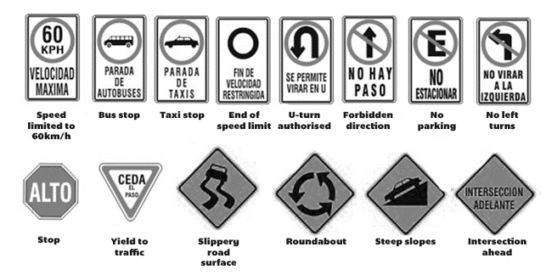

**Costa Rican radio stations**

Tastes and colours being different, we have tried to give you a panorama of Costa Rican radio. Among these typical Costa Rican radio stations, you will find a few that will allow you to experience the daily life of the "Tico" and the "Tica" in their car.

We hope that these Latin and international melodies will be a pleasant accompaniment to your tour of this superb country.

The Morpho team.

**Radios:**

**Besáme** : 89.9. Radio station famous for its latest romantic songs.

**Momentos Reloj** : 94.3. Popular radio station in Costa Rica, where all styles of music are mixed (many songs in Spanish).

**Z FM** : 95.1. For lovers of rhythmic music: salsa, merengue, bachata, cumbia and other types of dance music.

**Radio Nacional** : 101.5. Station de radio qui ne passe que des musiques nationales costariciennes.

**Radio U :** 101.9. A multi-style radio station that plays everything from Calypso de Limón to international pop/rock. It is a university-run radio station.

**Best Fm** 103.5. Music radio station (pop - rock - electronic) from the 70s, 80s, 90s and 2000s (mainly Anglo-Saxon music).

**Radio Hits**: 104.7. Pop/Rock/Indie music radio. If you're looking for a change of pace and want to listen to a bit of international music.

**Omega** : 105.1. You'll listen to Costa Rican comedians who speak a little colloquial Spanish and a lot of 'pachuco' (Costa Rican slang). A radio station that will arouse your curiosity.

**The main Costa Rican television channels**

**Repretel:** channels 4, 6, 11

**Teletica:** channel 7 (the historic channel, created in 1960)

**Canal UCR:** the TV channel of the University of Costa Rica

Best practice in sustainable tourism

**Respect for local populations**

Travelling opens you up to new cultures and new landscapes. We are committed to helping you discover sites that benefit local populations, so that you can experience Costa Rica in all its dimensions. Respect and sharing with Costa Ricans are, of course, fundamental values in the creation of your trip.

**Good practice when visiting a national park**

It is strictly forbidden to collect or take geological or biological elements in national parks. Respect the environment and try to reduce your impact on nature (noise, rubbish, flash cameras, etc.).

**Recycling and waste reduction**

Recycling is a common practice in Costa Rica, so don't hesitate to ask your hosts if you can't find the containers set aside for this purpose.   
The best waste is that which is not produced. We invite you to use water bottles rather than plastic bottles, straws made from biodegradable materials or metal and not to use plastic bags. We give preference to the most responsible service providers in terms of waste management.

**Water pollution and energy optimization**

Costa Rica is surrounded by two oceans and numerous rivers. The use of biodegradable sunscreens that respect the ocean should be encouraged. Similarly, no waste should be dumped in the ocean or rivers. We also recommend using biodegradable soaps and shampoos. Keep the use of air conditioning to a strict minimum. Turn off the lights and all sources of energy as soon as you stop using them.

**Respect for flora and fauna**

We ask you not to touch the animals and not to take photos with the flash. Many plants and animals can be toxic or dangerous, so please take care.

**Zero tolerance for the sexual exploitation of minors**

Sex tourism is a scourge that affects every country in the world. Unfortunately, it also affects Costa Rica. Morpho Evasions, as a member of Code of Conduct 𝐏𝐫𝐨𝐭𝐞𝐜𝐭 𝐓𝐡𝐞𝐦, would like to remind you that having a sexual relationship with an adolescent (minor) is an offence punishable by prison. Morpho Evasions has been involved in this fight for many years and reaffirms that there is and will be zero tolerance of the sexual exploitation and assault of minors.

**Costa Rican gastronomy**

Costa Rican cuisine is mainly based on rice and beans for its traditional dishes. However, there are several typical dishes.

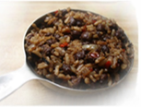

**Gallo Pinto**

Rice, beans, onions and spices, the great Costa Rican classic. It's part of every Tico breakfast. You won't want to miss it.

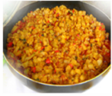

**Arracache Picadillo**

Arracache is a tuber that is peeled and cut into small pieces for special family occasions. It is often mixed with pumpkin and coriander.

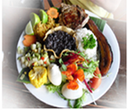**Casado**

A typical worker's dish, Casado is a complete meal comprising rice, beans, tomatoes, plantains, coleslaw and a choice of meat, poultry or fish.

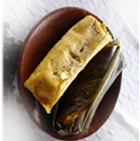**Tamal**

If there's one dish Costa Ricans can't live without at Christmas, it's Tamal. Made from maize flour, sultanas and pork, it is wrapped in a banana leaf and cooked in boiling water.

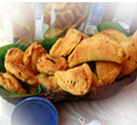**Empanadas**

Small fritters filled with apple, guava jam, cheese or seasoned chicken, these appetisers are part of everyday life for Costa Rican families.



**Tico Traditions and Folklore**

Costa Ricans are famous for their hospitality and friendliness. They will be delighted to share their traditions and culture with you.

**TICO (A)** = Costa Rican. This word comes from the excessive use of diminutives ending in -tico, -tica. Example: pequeñiticos (very small), gorditica (chubby), cerquitica (really close).   
  
**Pura vida**: Costa Rican expression used to say hello, goodbye, thank you, you're welcome, everything's fine. Ticos like to use it to say that they are "full of life".   
 **Soda (f):** small traditional restaurant where you can eat the special of the day, soups, fried chicken, "chicharrones", etc. at a good price.   
  
**Village fiestas:** Every village has its own "fiestas patronales", often held to celebrate its patron saint. These include rodeos, bullfights, parades on horseback, fireworks, barbecues and churros, as well as entertainment such as concerts, bombas, bandas, cimarronas and masqueradas.   
  
**The carreta de bueyes:** Lovingly painted by the craftsmen of Sarchi, it has been used for agriculture, construction and the transport of goods. A national symbol since 1988, the oxcart is on UNESCO's list of World Cultures and Heritage.

**Music, dances and karaoke** are always present at tico parties. Rhythms such as the Afro-Caribbean Calipso, salsa, cumbia and merengue bring joy to every celebration. The Marimba, Costa Rica's national symbol since 1996, is an instrument that was beginning to disappear from the cultural landscape. In Santa Cruz, Guanacaste, you'll find specialist marimba makers and players.

Costa Rica has had no army since 1948. The state budget is spent primarily on education (building and renovating schools, free and compulsory education between the ages of4 and 17), health (EBAIS, clinics and hospitals) and social housing. The country has **a literacy rate of 97%, with a patriotic and pacifist feeling felt in everyday life.**

